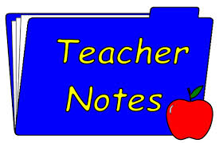

Congratulations 2nd Grade Readers:
1,164,144 Words Read in 9 Weeks

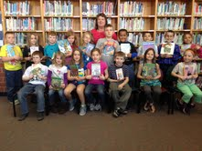

Reading – Synonyms, antonyms, homonyms, Myon reading

Language Arts- Daily Oral Language with “student teacher”

Math – Multiplication, Star Math Test

Science/ S.S. – Painted Lady Butterflies

Spelling words – Math terms

Andover YMCA reading reward field trip Wednesday morning.

